

GWAVA Inc.

|  |
| --- |
| GWAVA® Retain™ |
| Upgrade Guide |

“GWAVA” is a registered trade mark of GWAVA Inc, 100 Alexis Nihon, Suite 500, Saint Laurent, Quebec H4M 2P1

“Retain” is a trade mark of GWAVA Inc, 100 Alexis Nihon, Suite 500, Saint Laurent, Quebec H4M 2P1

“GroupWise” is a registered trade mark of Novell inc.

Contents

Upgrade Information 4

Upgrade Process 5

Retain 1 5

Retain 2 5

Upgrade for Retain 1 to 2 5

Upgrading to Retain 3 9

Retain Upgrade and Database Migration 9

Benchmark 9

Upgrade 10

Migration 10

Optional step: Upgrade indexing engine to Exalead. 16

**Copyright Notices**

The content of this manual is for informational use only and may change without notice. GWAVA Inc. assumes no responsibility or liability for any errors or inaccuracies that may appear in this documentation. GroupWise is a registered trademark of Novell, and copyrighted by Novell. Windows is copyrighted by Microsoft. GWAVA® is a registered trademark. Copyright © 2010 GWAVA Inc. All rights reserved. All other trademarks, service marks, and company names are properties of their respective owners.

**Technical Support**

If you have a technical support question, please consult the GWAVA Technical Support section of our website at <http://support.gwava.com> .

**Sales**

To contact a GWAVA sales team member, please e-mail info@gwava.com or call Tel: 866-GO-GWAVA (866-464-9282) in North America or +1 514 639 4850.

100 Alexis Nihon Blvd. suite 500

Montreal, Quebec

Canada. H4M 2P1

**Intended Audience**

This manual is intended for IT administrators in their use of Retain or anyone wanting to learn more about Retain. It includes installation instructions and feature descriptions.

**Organization**

The guide is organized into two sections: upgrading from 1 to 2, and upgrading from 2 to 3. While it is possible to upgrade directly from 1 to 3 and the steps are essentially the same, it is recommended to upgrade first to version 2 to ensure that the upgrade finished correctly before finishing the upgrade to the current version. Please see the applicable sections.

This guide also includes an instruction set for switching the indexing engine in Retain.

General use and management of Retain is covered in the Administrator Guide, please read that guide for setup and configuration steps and information.

# Upgrade Information

Upgrading Retain to the current version is a simple, automated process. Which steps are required for different systems depends on the version of the installed Retain system. A full upgrade from version 1 to version 3 includes three major steps:

* Update the Retain configuration database using an existing migration utility.

Retain 1, 2, and 3 use different licenses and will not function without valid licenses for each. If updating from 1 to 3, only version 3 licenses are required. Before updating the Retain system ensure that appropriate licenses are available. See a GWAVA sales representative to get the applicable licenses and plan the upgrade process.

* Update the message store database.
* Optionally change the indexing engine.

The configuration database is described in the version 2 update process. Updating the message store database is described in the version 3 update process. Both are described below.

**Configuration Database**

Retain version 2 introduced a changed location of the Retain configuration database. In Retain 1 the configuration database was located in a separate, embedded Derby database. Retain 2 moves the configuration to the existing Retain SQL database.

**Exalead**

Retain includes the option to install a new indexing engine for larger systems. Exalead can index massive amounts of data and is recommended for archiving systems with 1000 or more users. Exalead should be installed and run on a dedicated server for best performance. Exalead should not be run on the same machine as the Retain Server. If using Exalead, the system must be installed and running before the Retain Server is configured. For install and system requirements, please refer to the Exalead installation document.

If an administrator wishes to switch the index engine from Lucene to Exalead, it can be done at any time through the admin interface. However, the indexes must be rebuilt so the entire process can be very time consuming. For larger systems, though, the procedure may take quite some time. Please plan your systems accordingly.

**Retain Database changes and Improved Search Engine**

Retain 3 introduces improved ability with Lucene as well as updated and improved searching abilities in the Retain interface. To facilitate these changes, additional tables need to be added to the database. No modification of existing data is performed and updating the database is facilitated by a database migration utility. The migration requires roughly double the current space of the existing database to be available for use, as well as sufficient down-time for the Retain system while the migration is performed. Retain 3.0 must have an updated database to function, and should not be installed until a migration can be performed. **See the requirements and process for updating to Retain 3 before continuing.**

# Upgrade Process

## Retain 1 to Retain 2

The upgrade process from version 1 to 3 requires first the upgrade from 1 to 2, and then a second upgrade from 2 to 3. The upgrades steps are separate and have individual considerations. Please see the individual sections and read all instructions to properly plan the upgrade for your system.

## Retain 2 to Retain 3

Systems already upgraded to 2 can skip the first step and move directly to the upgrade process from version2 to 3.

# Upgrade for Retain 1 to 2

When Upgrading Retain from Retain 1 to 2, there are several objects to be aware of and update or migrate before the system will work. All the steps include:

* Backup your Retain System
* Upgrade Retain Server to 2
* Check for successful installation
* Run the migration wizard
* Upgrade all Retain Workers
* Upgrade all Migration tools
* Install Retain 2 license (If upgrading directly to version 3, this step may be skipped)

Optional upgrades:

* Exalead

The steps are covered in detail below:

1. **Backup your Retain System**. Should the wrong option be selected during the Retain Server installation, the Retain Server configuration can be overwritten. Connection and access to Retain data requires identification keys stored in the configuration. The Retain Server settings and configuration cannot be lost.
2. **Install Retain Server 2.x**. When Retain is installed, it will detect that a previous version of Retain is installed and prompts whether to upgrade or overwrite the installation. Select the option to **Upgrade, preserving configuration**. If overwritten, Retain Server must be restored from backup and the install upgrade must be restarted.
3. **Check for successful installation.** If the installation upgrade has been successful, the Retain Server home page, (http://<RetainServer_IP_or_Hostname>/RetainServer), should display the following notice:

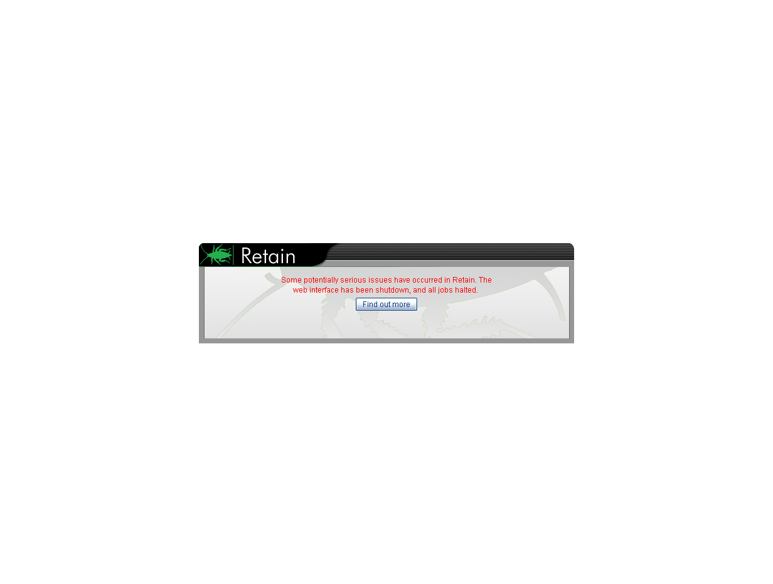

Selecting the ‘Find out more’ button will display the next notice:

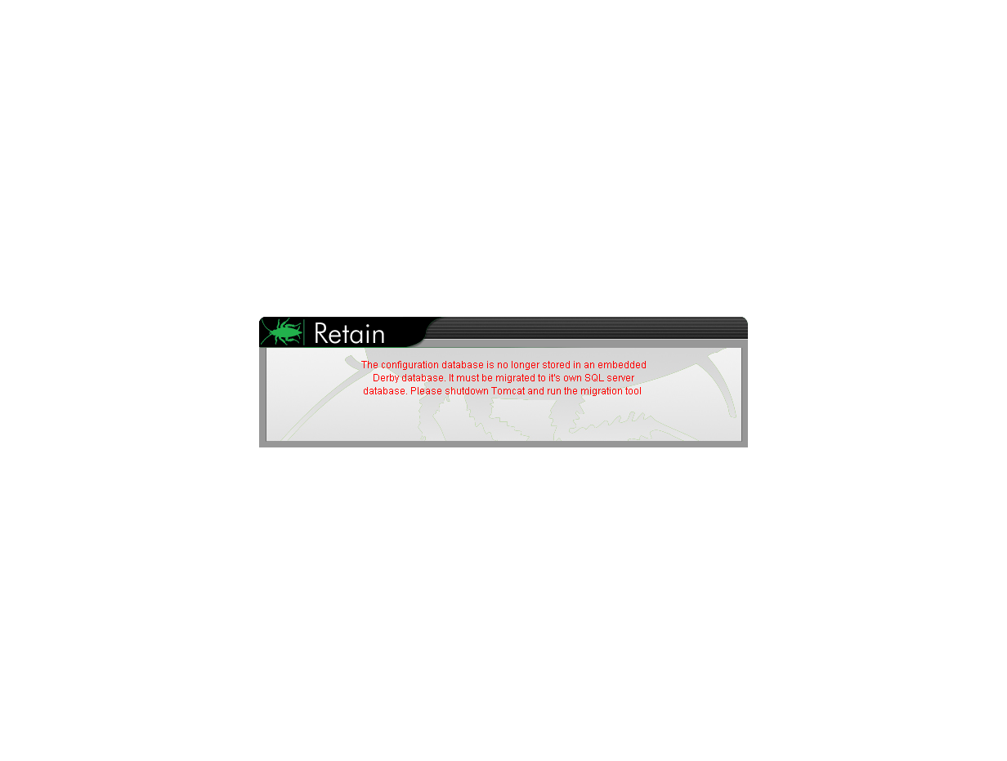

1. **Run the migration tool.** The migration tool is located in the ‘migration’ directory in the Retain download. Browse to that directory and run the migrator on the Retain Server.

**Windows**

Locate and run the migrate.bat file. The migration utility assumes the default path to the Retain Server installation. By default, the components are located at: C:\Program Files\Beginfinite\Retain\RetainServer

**Linux**

If under linux, you may need to add permissions the migrator by typing:  
chmod +x migrate.sh

The migration utility needs to know where the current Retain Server resides in the file system. Run the migration utility and place the working directory of the Retain Server as an argument. Use absolute pathing.

./migrate.sh <path to Retain Server>

On either Linux and Windows systems, the migration utility places the default locations between brackets before the prompt. To accept the system defaults simply press <Enter>. In most cases, the defaults will be correct and can simply be accepted. The below example assumes Linux default file paths for the Retain Server components.

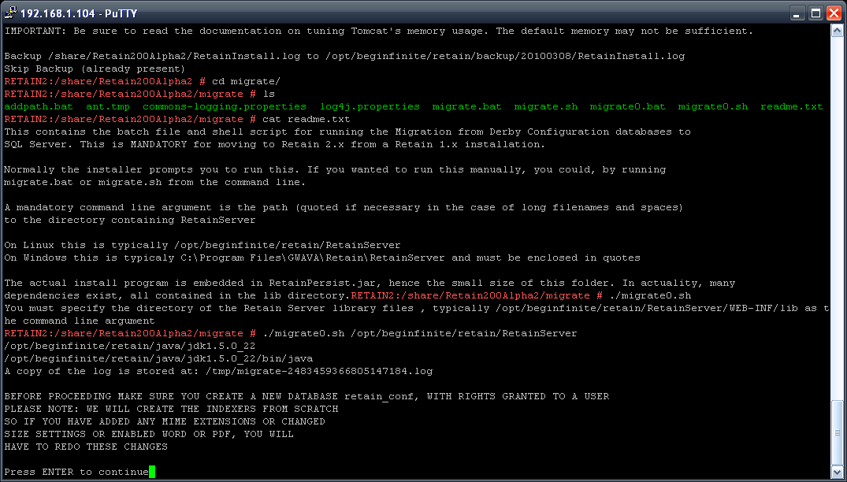

Read the notice, and hit enter to continue.

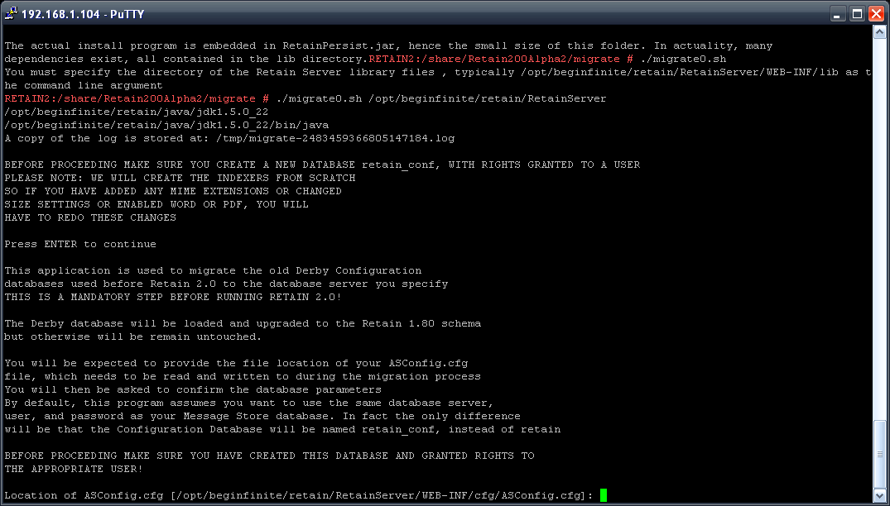

The migration program will inform you of what it will do and what information is required. The ASConfig.cfg file is located in the …/retain/RetainServer/WEB-INF/cfg directory.

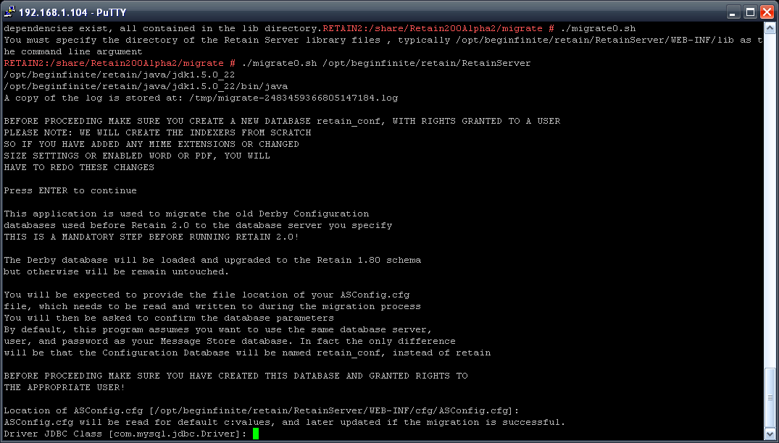

The JDBC class location must also be provided. Default is shown.

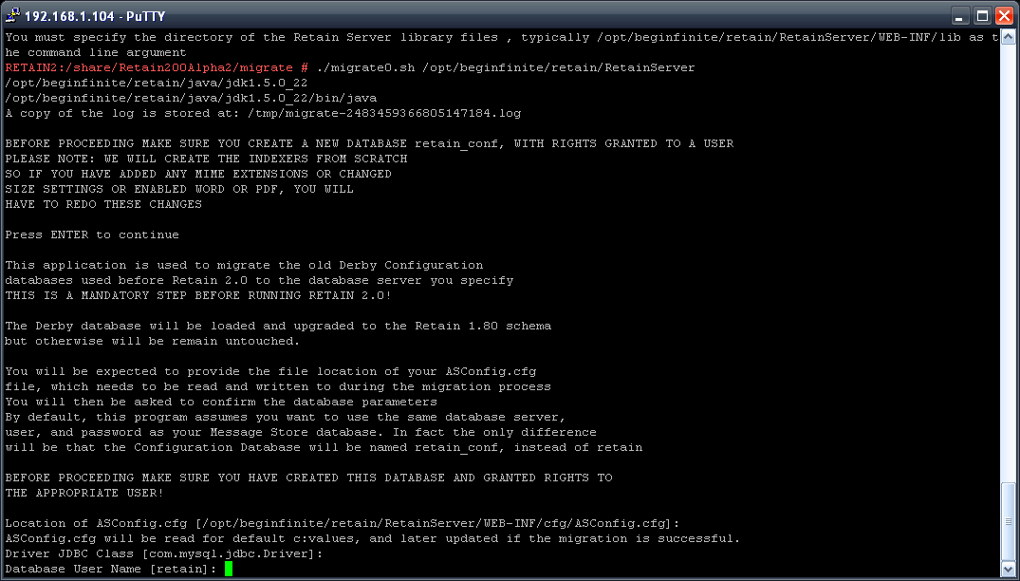

Authentication to the database server hosting the retain database is required. The defaults are listed in the current Retain Server configuration. First provide or confirm the user name.

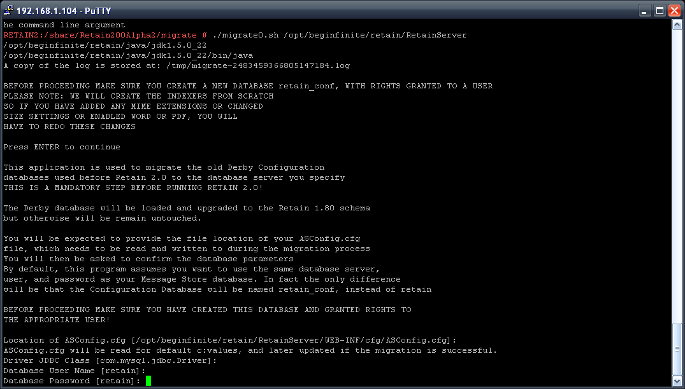

Next confirm or provide the password to the database .

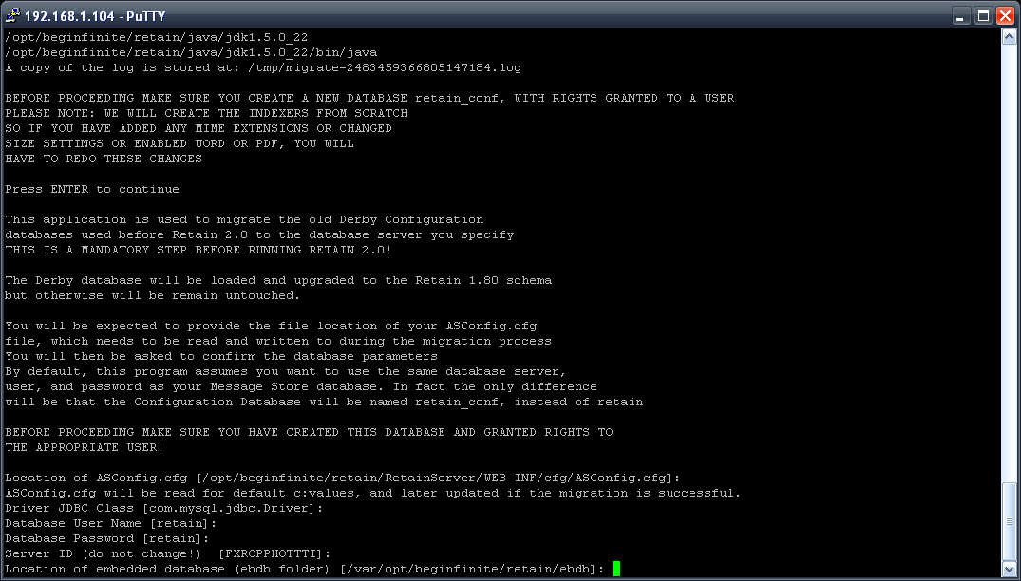

The ebdb database location is required. Unless changed during initial Retain 1.x install, this can remain as default.

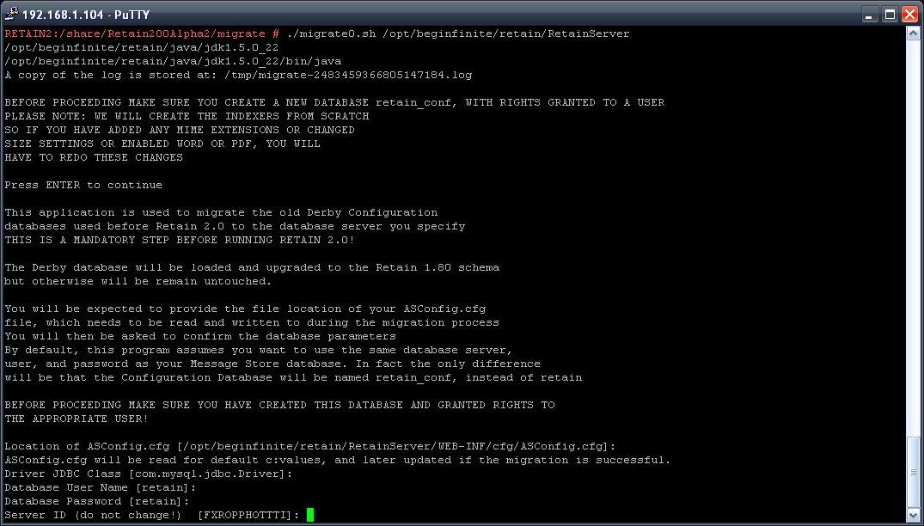

DO NOT CHANGE the Server ID unless specifically instructed to by Support. Accept default by pressing <enter>.

Confirm your settings.

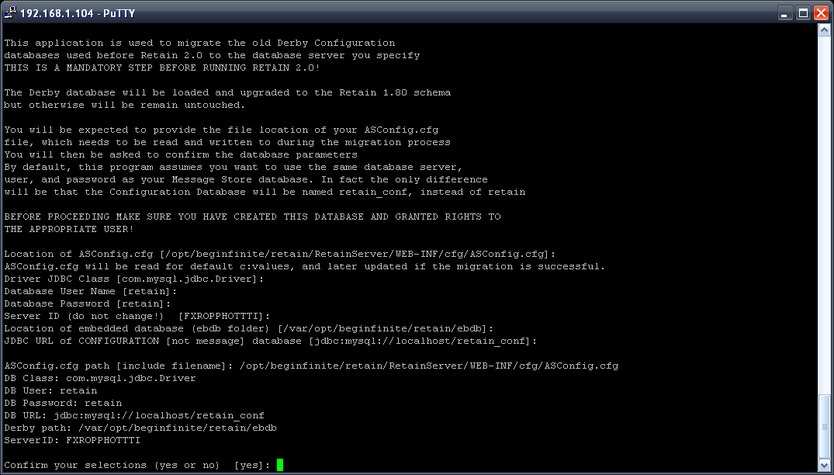

Look over the above information and confirm the correct information. Type ‘no’ to correct any information.   
After selecting ‘yes’, the migration utility will setup the retain database with the information just provided along with the current configuration settings in the Retain 1.x configuration database.

This will migrate all jobs, schedules, profiles, and worker information from the 1.x server to the new Retain server. After the migration utility has completed, if tomcat has not been started, it should be.

The Retain Server should be fully accessible as usual with the same username and password.

1. **Upgrade all workers and re-upload the bootstrap files for all Retain Workers.** All Retain Workers must be updated or scheduled jobs assigned to an un-updated worker will not run. Retain 1.x workers cannot communicate with higher version Servers. The new bootstrap will be named RetainWorker2.cfg. Run the Retain installer on each Retain Worker box and update each Retain Worker.
2. **Upgrade all migration tools.** If there are any GroupWise Archive Migration Tools or GWArchive M+ Archive Migration tools active in the system, they also must be replaced with new migration tools from the current Retain download. (..\Retain\tools\Migration Tools)
3. **Update your license.**  New versions constitute new systems which require new licenses. There is a 30 day grace period to update the license; however, it is best to update the license while working on the server instead of waiting for the grace period to expire. Download or locate your Retain 2 license and upload it to the Retain Server. Log into the Retain Server as admin, select the **Configuration | Licensing** page and upload your new license.

The Retain system has now been updated to version 2. Next continue below to upgrade to version 3.

# Upgrading to Retain 3

Retain 2 requires two steps to complete the update to Retain 3: Database migration and Retain program update. The Retain program update should be performed first, which then triggers the database migration wizard automatically on next login. After the upgrade, Retain 3 license(s) must be immediately uploaded to begin Retain functionality.

## Retain Upgrade and Database Migration

Retain 3 makes a few changes to the Retain database making a database migration necessary in order to upgrade previous versions Retain. In order to facilitate the migration process, a migration utility has been created and included with the main Retain 3 download.

Because the migration may take quite some time, and because upgrading Retain renders the system unusable until the migration has completed, careful planning is strongly recommended when dealing with the migration.

If questions persist, or if problems are encountered in upgrading Retain and migrating the database, please contact Retain support.

In order to plan the Retain upgrade and migration, several things are required:

* Retain 3 package downloaded to desired server
* Migration temporarily requires free disk space, up to double the current disk space of the current Retain database.
* Retain 3 licenses
* Migration benchmark completed – Highly recommended (but not required)
* Sufficient time (according to benchmark estimate)

Ensure that all required materials are available before beginning the upgrade and migration.

## Benchmark

The benchmark utility is a simple, command-line utility which should be run from the Retain Server, which estimates the time required for the database migration to complete. Due to the great difference in sizes between databases and hardware limitations, no general rule or statement can be provided for an estimate. Some migrations will take hours and others a week or longer.

The benchmark utility provides an accurate estimation through a simulated migration of the database with a very limited scope, (~250K records). Disk IO and processor speed are the main limitations for the estimated time frame, and for performance reasons these should be taken into consideration. It is important to run the benchmark utility on the Retain Server for the estimate to be accurate.

The benchmark utility grabs the configuration file for the Retain Server, which contains the database connection information, then asks for confirmation on the credentials. When confirmed, the benchmark performs a simulated database migration for the first 250K records and utilizes the performance data for an estimate on the rest of the database. During this simulation the database is unchanged by the utility.

The utility is located in the main Retain 3 download in an additional folder titled ‘benchmark’. Locate the ‘benchmark’ folder and select the appropriate executable.

* benchmark.bat – for Windows Retain Server
* benchmark.sh – for Linux Retain Server

With the appropriate executable, run the benchmark utility on the Retain Server. The benchmark will automatically shut down Retain for the duration of the simulation, as well as checking the Java version installed. If Java installation is required, follow the appropriate prompts.

The migration asks for confirmation on the location of the asconfig file and the database connection driver. Default installation paths are shown and should not be modifiedunless the Retain Server was installed to an alternate location.

Warning: The benchmark utility asks for confirmation on the retain database user’s password and it is displayed. Plan to run the benchmark accordingly.

Once the information has been confirmed or provided, the benchmark automatically runs and after completion displays the pertinent information. The process may take several minutes depending on the different system.

The important information the benchmark utility displays is the time estimate.

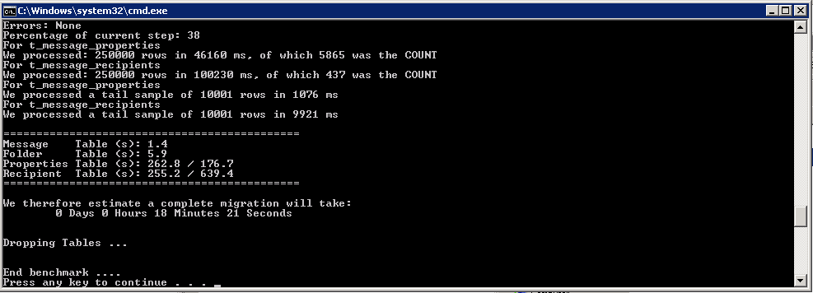

NOTE the estimate. This will be the approximate time required. Only when this time is available upgrade the Retain Server.

## Upgrade

The upgrade process is quite simple and straight-forward; re-install Retain utilizing the Retain 3 installation files. The upgrade is nearly identical to a new install, except the administrator should select the ‘upgrade’ option during the install wizard. Take care to NOT overwrite the Retain Server system.

## Migration

Browse to the Retain Server, (http://<ServerIP>/RetainServer). On restart after the upgrade has been completed, Retain 3 will initialize the database migration utility instead of the standard login.

Only a user with Administrator rights can start the migration.

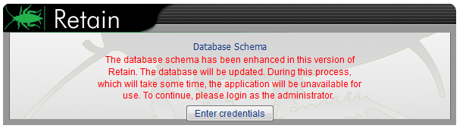

Select the ‘Enter credentials’ button and login as an administrator.

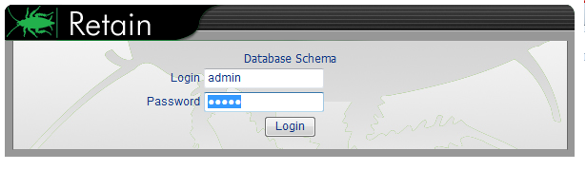

In order to update the database, Retain 3 must first prepare the schema. This process will take a few minutes.

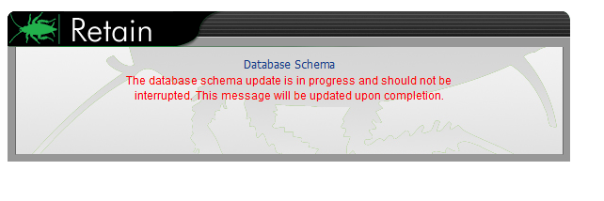

Once the Schema is prepared, Tomcat must be restarted manually. Restart Tomcat and browse once again to the Retain Server.

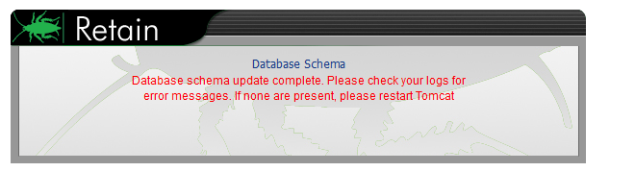

The database Migration also requires an administrator’s credentials to begin.

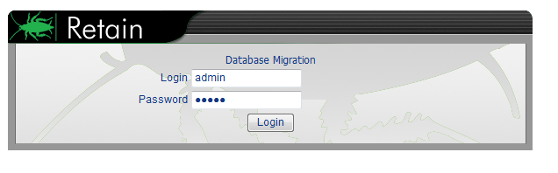

This page should only appear for a few moments, and then resolve to the next screen.

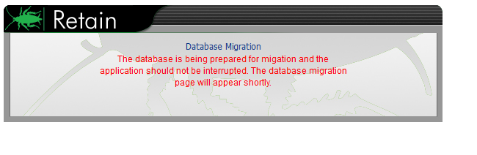

To begin the database migration, select the ‘Migrate’ button.

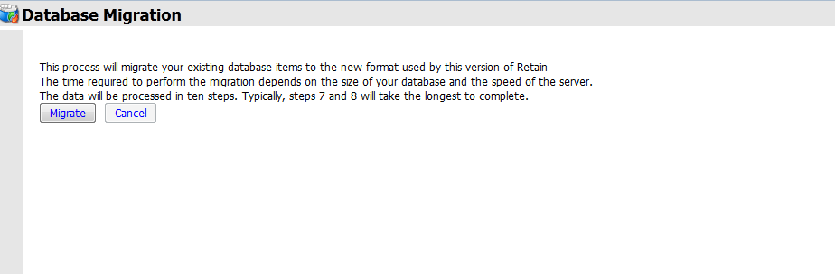

Only MySQL Database users will see this page:

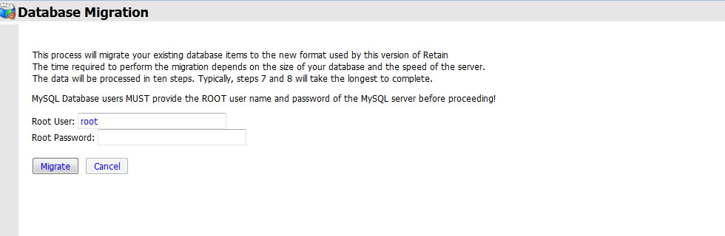

MySQL requires the root or super user credentials to modify the database, and it must be provided. Once the ‘Migrate’ button is pressed, the migration will begin.

The migration process itself consists of 10 different steps. Each step has a ‘Raw Progress’ bar which displays the amount of work or records each step must complete.

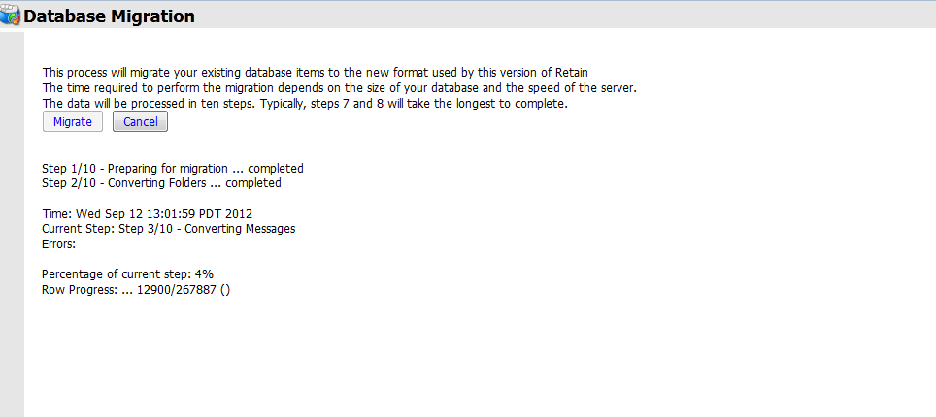

This process will take as much time as the benchmark estimate stated. Make plans accordingly.

When the Migration is complete, the Retain page displays a completion status. Duration, individual step completion status, and error count is displayed. If any errors have been encountered, please contact Retain Support.

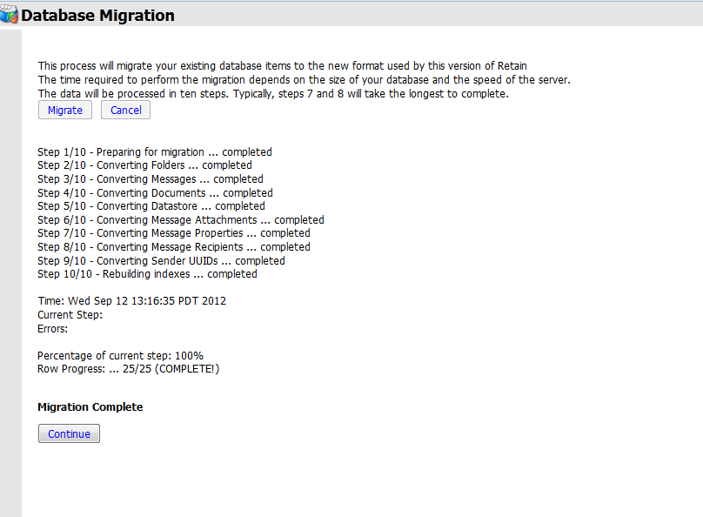

Select the ‘Continue’ button to dismiss the report and complete the migration. The following page is then displayed.

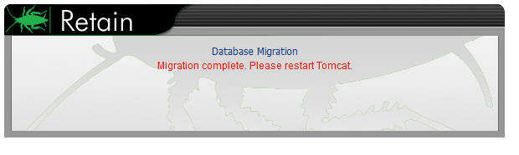

Restart Tomcat to complete migration.

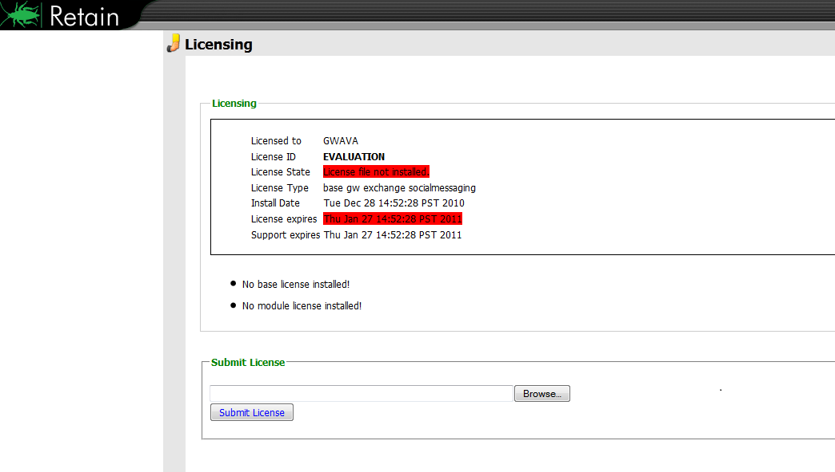

With the next login, the Retain Server displays the license page. Retain must have Retain 3 licenses. Retain 3 will not function with licenses from previous versions.

Select the ‘browse’ button and locate the appropriate license. If the license cannot be found, contact a Retain Sales representative.

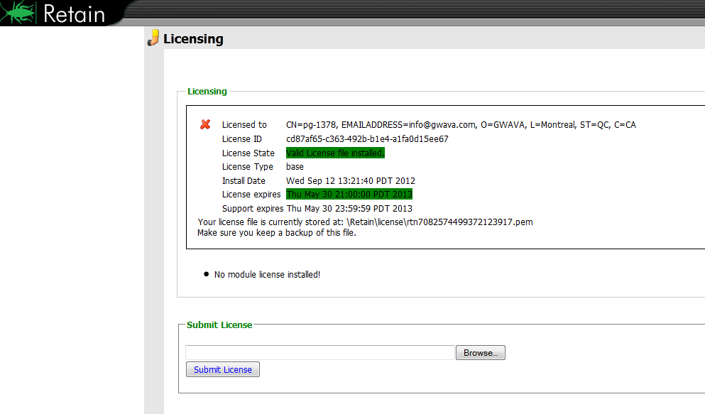

Once the licenses are submitted, simply refresh the page and the Retain system is ready for operation.

While Retain is currently operational, it is highly recommended to upgrade the Retain Workers as well.

# Optional step: Upgrade indexing engine to Exalead.

The Exalead indexing engine is not required, and the system can be switched from Lucene to Exalead at any time. However, the index engines are not compatible with each other and have no way to export the indexes between them, causing a need to re-index the entire mail archive each time the index engine is changed to ensure full coverage. Re-indexing the archive will take substantial amounts of time, and switching the indexing engine should only be run during a ‘quiet time’ when there are no jobs scheduled to run.

Exalead allows much more flexibility and options in searching and scaling. However, Exalead does require a separate physical machine with robust hardware. For a full list of Exalead requirements and install instructions, see the Exalead Install document. Switching to the Exalead indexing engine will cause some server downtime.

Before you begin the migration to Exalead for the indexing engine, you must first have Exalead installed and working. Log into the Retain Server management console as Adminitrator, and ensure that:

* The Retain System has been backed-up.
* Exalead server has been installed, setup, and is accessible.
* No deletion manager jobs should be running, or set to run.
* Indexer status is set to ‘0’. On Retain Server status page, the “Total emails in memory queue waiting indexing” should show ‘0’. If this is not set to ‘0’, and no job is running, contact support before performing the index engine migration.

From this point on, actual changes will be made in your Retain Server system. To change the index engine, perform the following steps

1. As admin, log into the Retain Server management console and browse to the **Configuration | Server Configuration** page and select the **Index** tab and click on the ‘Migration Steps’ link to spawn the migration steps window.

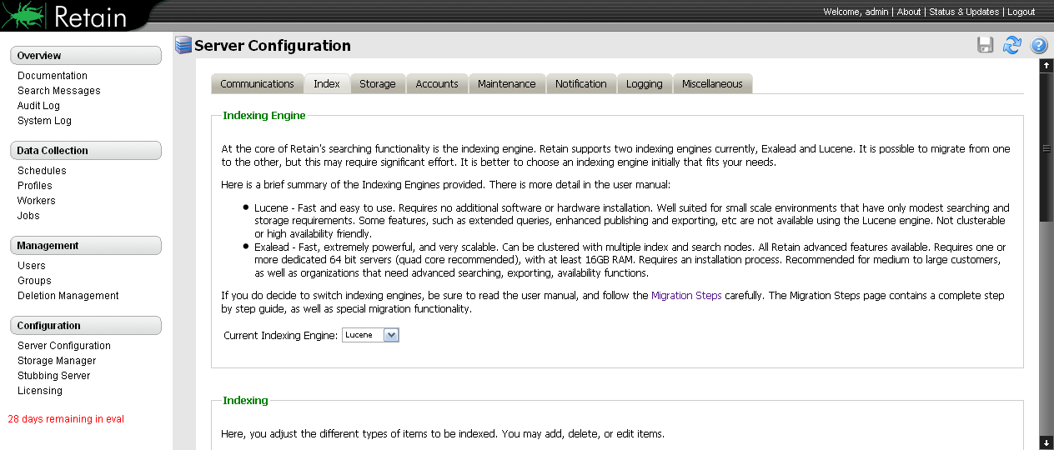

Open the migration link in a new window or tab.

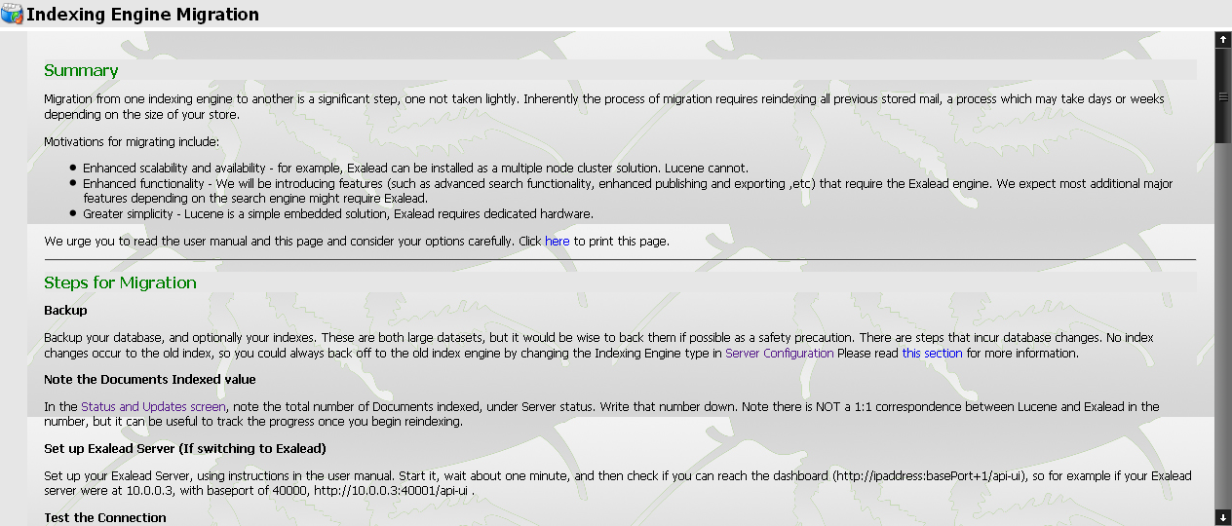

This window has links and information on the migration as well as the migration settings further down the page. LEAVE THIS PAGE OPEN.

1. Scroll down the page to the link to the Indexer Reset page.

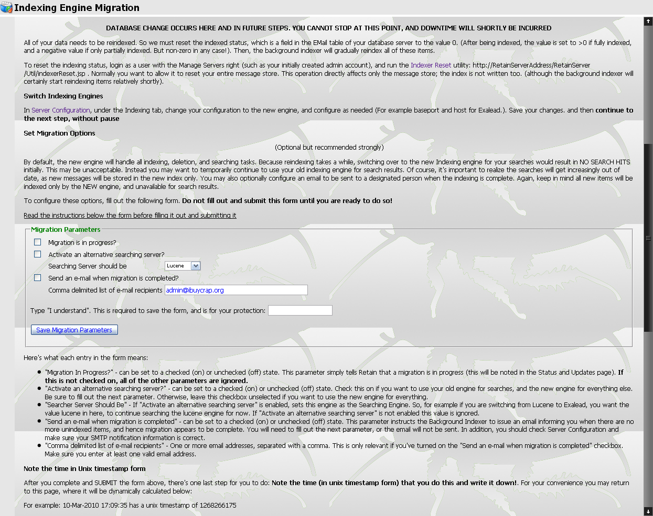

Open the link in a new page or tab. http://RetainServerAddress/RetainServer/Util/indexerReset.jsp

By default, the Indexer Reset page should look like the picture below. (Pay attention to the Unindexed Items (DB): number. It should read ‘0’. If it does not, do not proceed unless under the instruction of support.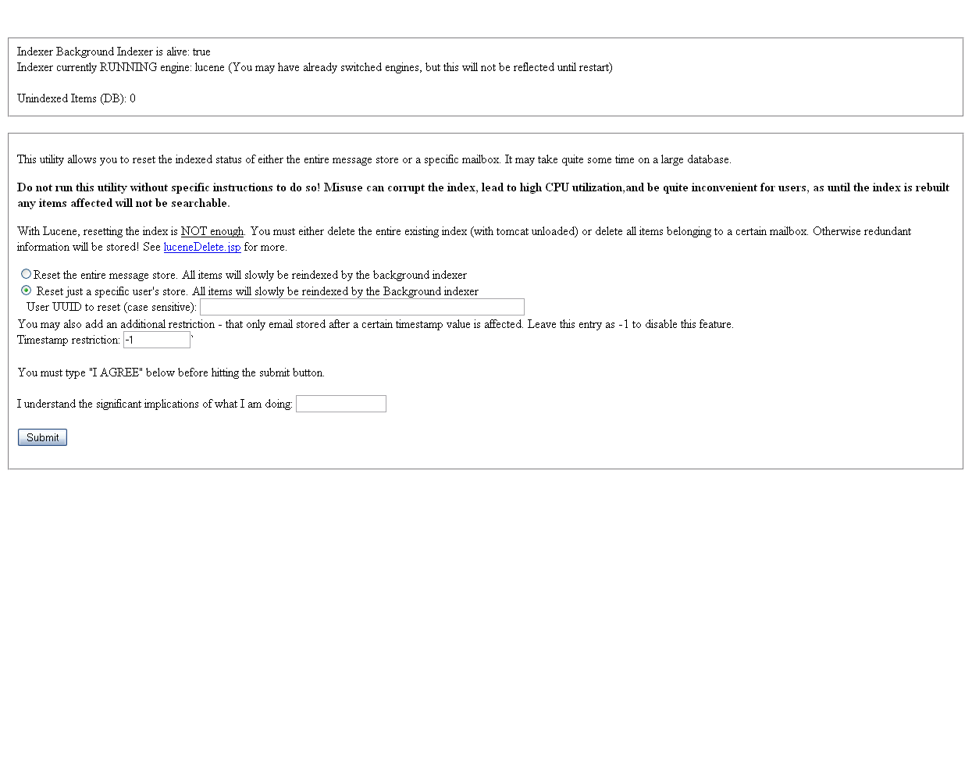

**The next few steps need to be performed with very little time delay between them. No more than a couple minutes.** If not switched soon enough, the indexer reset switch will cause Lucene to re-index, instead of causing Exalead to index the message store, resulting in empty search results when switched to Exalead and slow responses due to Lucene re-indexing the message store. Read through the next steps and decide settings before proceeding. These steps must be completed in the order specified.

1. From the Indexer Reset page, Select **Reset entire message store**. Type “**I AGREE**” in the dialog after reading the warnings. Select **Submit**.

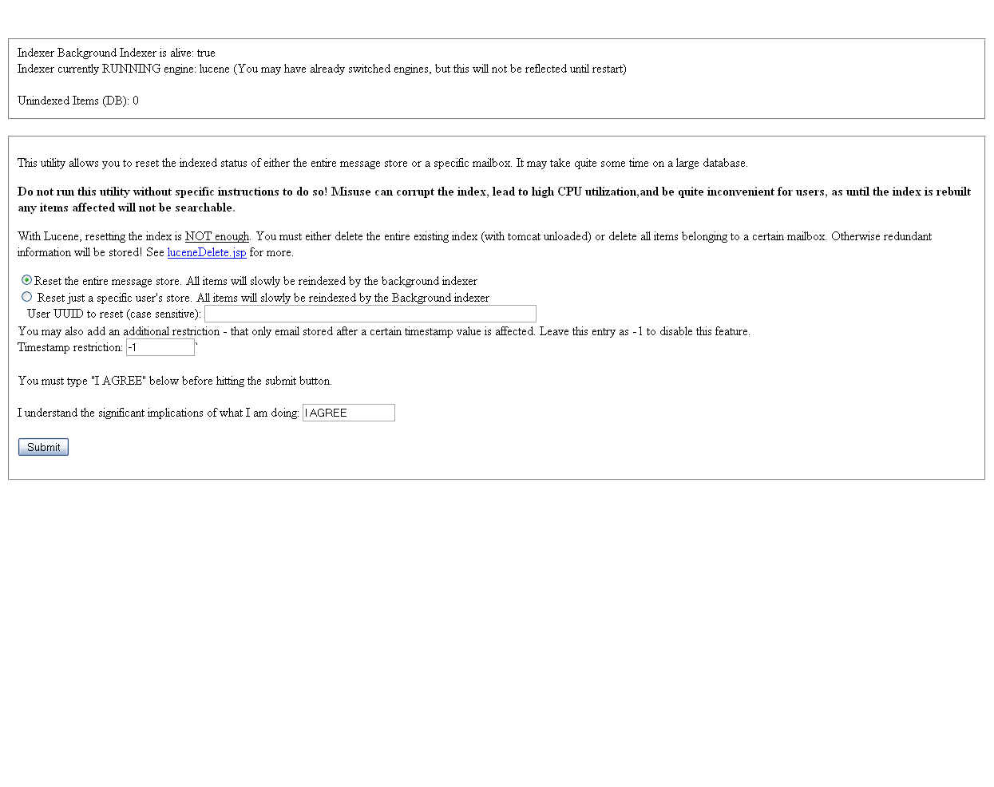

Proceed **without delay** to the next steps

1. THIS STEP MUST BE DONE QUICKLY AFTER RESETTING THE INDEX. Go the server configuration in the Retain Server admin page, and switch indexer engine to ‘exalead’.

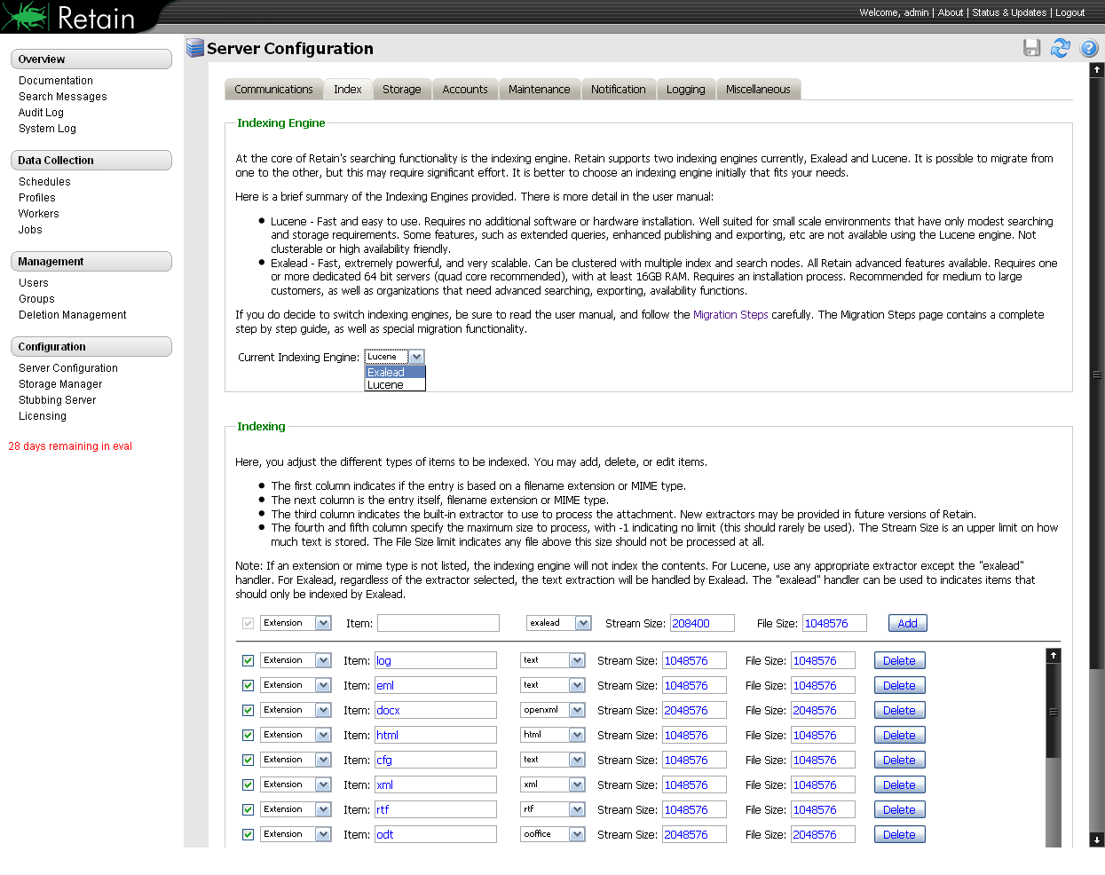

After selecting Exalead as the indexing engine, input the connection information (IP address and base port, the default base port is 10000).

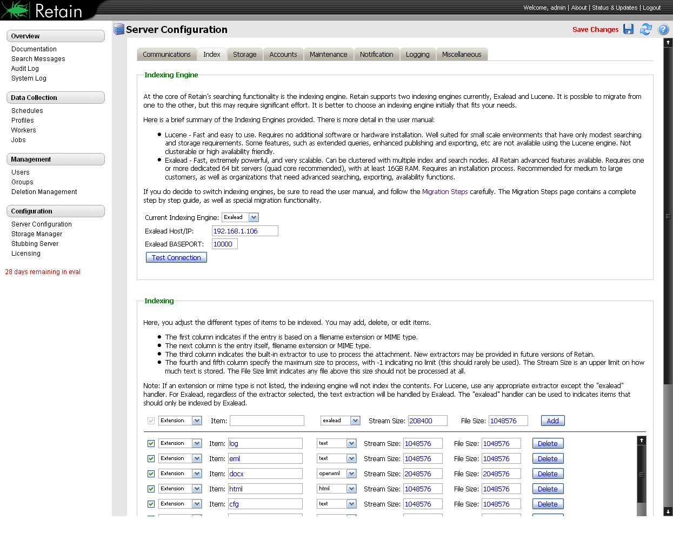

After all changes have been made, select the **Save Changes** button.

1. Go to the **Migration Steps** page and Select, migration in progress, and select to **Send an e-mail when migration is completed**. Specify a destination address.

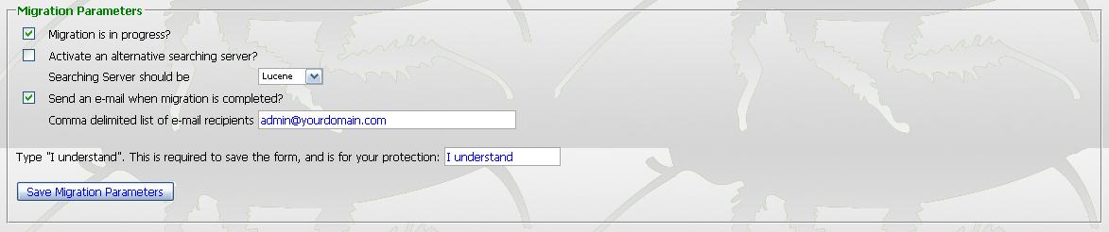

1. Activate an alternative searching server if desired.

While Exalead is indexing the archive, there will be no mail in the index to be searched through. Depending on how much mail is in the archive, the indexing operation may take a very long time. To have the searching features of Retain available while the archive is processed, specify a separate searching server. In this case, it would be Lucene. The only downside to this operation is that any new mail added to the system during the indexing operation will not be added to the Lucene index, and will not be available to search until Exalead has finished and the search engine has been changed to Exalead.

1. After the settings are correct, type “**I understand**” and select **Save Migration Parameters**.
2. Restart Tomcat on the Retain Server system. When Tomcat starts back up, the settings will be cemented and the archive will be re-indexed into Exalead.

During the indexing process of Exalead, the statistics of the Retain Server Status and update page should rapidly increase. It is one way to monitor the progress of the migration. (The screen shot shown is before the migration is started.)

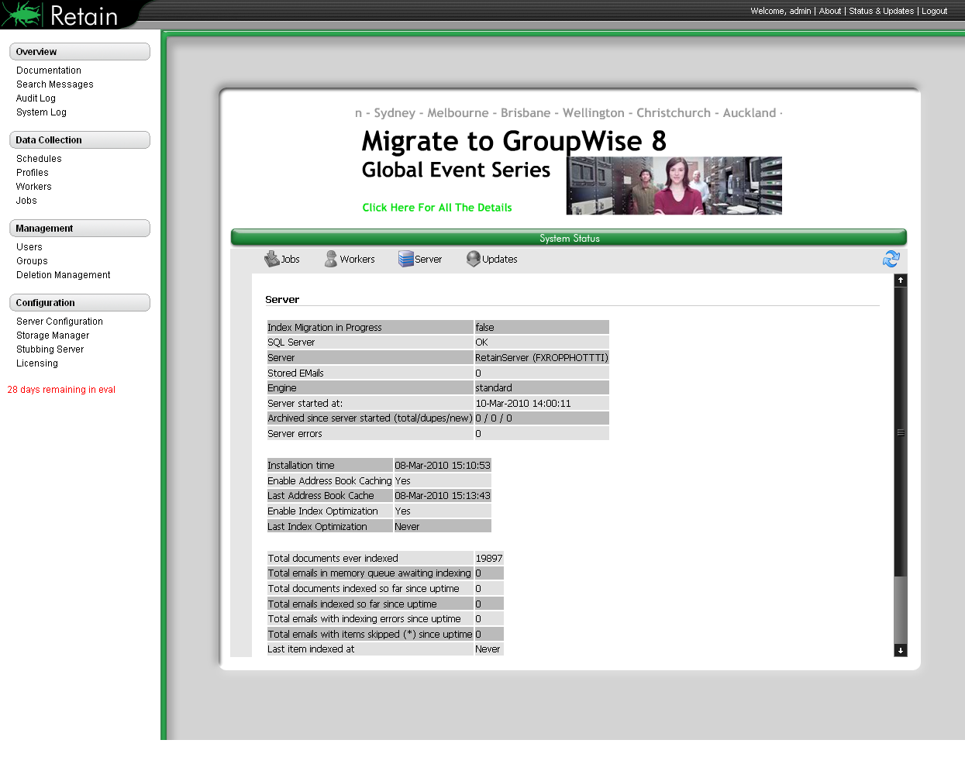

1. When the migration compete email arrives, return to the Migration Steps page and unselect the **Migration is in progress** setting, type **I understand,** and **Save Migration Parameters**.

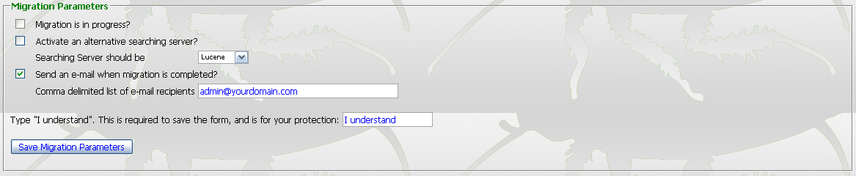

Even though Lucene has been unselected, it will still exist with all the indexes until removed. Again, Re-indexing may take a long time depending on the hardware of the Exalead system, the size of the archive, and the speed of the connecting network. Allow for plenty of time for the indexing to be performed. Time may range from several days to several weeks for extremely large systems.

Once it has been determined that Lucene is no longer wanted or needed as a backup for the system, to save system disk space, the Lucene index should be removed from the system. This is not a necessary step, though it does free up system disk space that currently holds duplicate data that now resides in the more robust Exalead system.

To remove the Lucene Indexes, login as admin to the Retain Server, open a new window or tab, and browse to http://Retain_Server_Address/RetainServer/Util/luceneDelete.jsp to remove the users one by one according to UUID. The lucene delete page is also linked form the **Indexer Reset** page. To manually delete the Lucene indexes, remove the contents of the <storage area>/index directory. There should also be a copy of the index directory in the backup folder of the storage area. This measure is not required.